|  |
| --- |
| **ACTS CDAC Delhi** |
| **E-Examination System** |
| SRS Document |

|  |
| --- |
| Group-6 [PGDAC]  4/18/2022 |

**Software Requirement Specification**

**For**

**“E-Examination System”**

**Submitted to**



**Center for Development of Advanced Computing**

**C-DAC’s - Advanced Computing Training School, New Delhi.**

Plot No. 20, FC-33, Institutional Area, Jasola, New Delhi 110025 New Delhi  
New Delhi -110025 (India).

**Telephone:** 9810263864 **e-Mail:** abhinavd@cdac.in

**Website: -** https://www.cdac.in/

**1. Introduction:**

The following subsections of the SRS document provide an overview of the entire SRS.

**Purpose:**

The purpose of the project is to provide online facility to *Institutes* to conduct online exams and to Students to give online exams. Institutes admin can enter and edit the questions along with the students list. Also they can view the result. Students can login and give their respective exams and view their score then and there.

**Scope:**

The website to conduct online examination is “**E-Examination System”.** This website provides facility to institutes admin to conduct online exams. In turn student can login with their name and password to give the exams and can view their result then and there. Institutes admin can also view the result of their students.

**Objective**:

E- Examination can reduce the hectic job of assessing the answers given by candidates manually. The main objective of this website is to conduct online exam and allow student take the exam at their own place.

**Benefits:**

This website reduces the manual work, maintaining accuracy, increasing efficiency and saving time. Also institutes need not go to develop a new software

each time, instead they just register and conduct a test. For students, it saves time of going to far away centers and also they can view their result then and there.

E- Examination System is a web-based application website to manage online general examinations, viva, lab-exam and competitive exams. Through this website student can register for the exam online. They will get the schedule of the exam online. And they can appear for the exam online. So there is no need to walk around everything can be done at this at their own place. Once the exam is over the result will be displayed as per schedule.

**Abstract:**

This project is helpful for students to practice different mock examinations from this site. In current generation lots of the examinations like GRE, CAT, and MAT…etc. is conducted through online system. This project will help students to get practiced to online examination method by taking mock tests from this web portal. E- Examination portal is implemented in 2 modules student examination module and examination admin module.

**Intended Audience**

**E- Examination System**fulfills the requirements of the institutes to conduct the exams online. They do not have to go to any software developer to make a separate site for being able to conduct exams online. They just have to register on the site and enter the exam details and the lists of the students which can appear in the exam.

Students can give exam without the need of going to any physical destination. They can view the result at the same time. Thus the purpose of the site is to provide a system that saves the efforts and time of both the institutes and the students.

### **Team Member List:**

**Pradip Mahadev Mane (210910120012)Swarali Vivek Kulkarni (210910120033)Mayuri Madhukar Bhise (210910120006)**

**Project Timelines: - (Total: 120 hours)**

**Group Form: - 15 Jan.**

**Project Title Justification: - 25 Jan.**

**Abstract: - 31 Jan.**

# Assumptions and Dependencies

# Assumptions

* There is an active internet connection with the system.
* The system has an internet browser installed.
* Users know the English language, as the user interface will be provided in English .

## **Dependencies**

* Users should remember User Name and Password for authentication while confirming his or her authenticity in the whole authentication process.

**Product Functions:**

* User can Register On Portal For Student.
* Admin and Student Both can Login on Portal to Their Respective Dashboard.
* Admin can see All Students In his Login, He can set Exam, Add, Update, Delete Questions, and View Result of All Students.
* Student can see his Profile, All the Available Exams, and Start Exam Also Can View his Result.

# User Classes and Characteristics

#### Database Connection Class:

* The Database Connection Class contains attributes pertaining to users Java Database Connectivity (JDBC).

#### Java Class:

* The Java Type class can be used to access data of register, login, Add Question, Examination, logout.

# 

# Operating Environment

#### Hardware Platform:

* Web Browser’s running on Windows, Linux, and Mac OS.
* Almost All Modern Browser’s Support E-Examination System.

#### Software Platform:

* **Front End Technology:** HTML, CSS, JSP, Bootstrap.
* **Back End Technology:** MySQL Database, JavaScript, JDBC, Tomcat.

#### Supported Tools:

* Eclipse IDE, MySQL Workbench.

# Design and Implementation Constraints

* User interface is only in English. No other language option is available.
* Users can log-in only with his assigned E-Mail ID and Password.
* Limited to HTTP.

# User Documentation

User documentation mainly comprises the authentication system. It will give all the minute details about the authentication process, if any user has any query about any module or functionality, one can refer to it and see how to proceed for the authentication process. This report is the complete documentation of the authentication process. It gives complete details about the authentication process, its functionality, users, software used, hardware requirement, environment and so on.

## **External Interface Requirements**

## **User Interfaces**

The main element is webpages using HTML5. The pages will use JavaScript. The website will be responsive. bootstrap will be used for the CSS and styling of the webpages. The webpages will be rendered on the server-side using JSP.

## **Hardware Interfaces**

The user-end system can be either a smartphone or a computer device. The application supports all major web browsers. The web browser should be JavaScript enabled.

## **Software Interfaces**

In software interfaces, JSP Servlet and JDBC are the back-end technology used along with MySQL Database. The front-end technologies include HTML, CSS, Bootstrap, JavaScript. Data will be communicated between these interfaces accordingly.

## **Communications Interfaces**

## The main communication interface for interacting with the System will be the web Browser using HTTPS and HTTP requests.

**System Features**

* Admin Login
* Student Registration Module
* Student Login
* Update Questions
* Delete Questions

**External Interface Requirements:**

**User Interfaces:**

**Admin Login Screen:** Fields available on this screen are:

Login Name

Password

**Entering Questions:** Various Fields are:

Questions

Options (4)

Correct Answer

**Exam Details Screen:** Various Fields are:

Exam Name

No. Of Quest ions

Time Limit

**Student List Screen:** Various Fields are:

Student ID

Student Name

**Student Login Screen:** Various Fields are:

email

Password

**Student Taking Exam Screen:** Various Fields are:

Display Of Question With Options

Control Buttons To switch questions

**Result Displaying Screen:** Various Fields are:

No. Of Correct Questions

No. Of Incorrect Questions

No. Of Unattempt Questions.

Total Marks.

## Result (Pass/Fail)

## **User Registration Module**

In the registration module, the user will have to provide following inputs:

|  |  |
| --- | --- |
| **Id** | **int(3) UN zerofill AI PK** |
| **studentName** | **varchar(30)** |
| **Email** | **varchar(25)** |
| **Address** | **varchar(55)** |
| **Education** | **varchar(25)** |
| **Uname** | **varchar(25)** |
| **Upass** | **varchar(25)** |
| **Confmpass** | **varchar(25)** |

## **Admin Login Module**

## During the login process, the admin has to enter his registered email. The user has to recall the registered Password.

|  |  |
| --- | --- |
| **id** | **int** |
| **email** | **varchar(25)** |
| **password** | **varchar(25)** |
|  |  |

# Add Question Module

# In this Module Admin is able to add Questions to existing database

|  |  |
| --- | --- |
| **questionID** | **int(3) UN zerofill AI PK** |
| **question** | **varchar(55)** |
| **option1** | **varchar(145)** |
| **option2** | **varchar(145)** |
| **option3** | **varchar(145)** |
| **option4** | **varchar(145)** |
| **answer** | **varchar(145)** |
| **subjectTopic** | **varchar(145)** |
|  |  |

# Result Report Module

# In this Module Result of student Exam has been Reported.

|  |  |
| --- | --- |
| **student_id** | **int UN** |
| **student_name** | **varchar(145)** |
| **correct_answer** | **varchar(145)** |
| **wrong_answer** | **varchar(145)** |
| **test_marks** | **varchar(55)** |
| **examtime** | **timestamp** |
| **subjectTopic** | **varchar(145)** |
|  |  |

# Student Result Module

# In this Module Result of the Student has Visible to Student in his Login.

|  |  |
| --- | --- |
| **studentId** | **int(3) UN zerofill** |
| **questionID** | **int(3) UN zerofill** |
| **hitAnswer** | **varchar(145)** |
| **examdate** | **timestamp** |
| **subjectTopic** | **varchar(145)** |
|  |  |

# Standards & Conventions

# ANSI/IEEE for SRS document Format.

**Technologies Used: -**

**Tomcat 9.0**

**MySQL**

**Java Server Pages (JSP)**

**JDBC**

**Software System Attributes:**

\***Security**: Only authorized users will be able to access the website by entering the correct login name and corresponding password.

\***Maintainability**: The website can be maintained in present or future. It will be easy to incorporate new requirements in the individual modules.

\***Portability**: As the website is online so will be easily portable on various systems. The website will be also easily portable on any OS based system that has MYSQL installed.

**Design and Implementation Constraints**

**Project Architecture Diagram:**

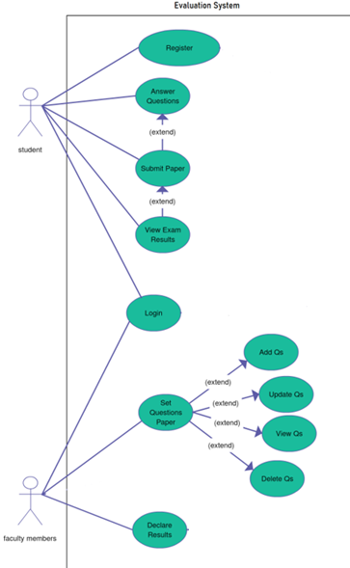

**DATA FLOW DIAGRAM**

A DFD also known as ‘bubble chart’, has the purpose of clarifying system requirements and identifying major transformations. It shows the flow of data

through a system. It is a graphical tool because it presents a picture. The DFD may be partitioned into levels that represent increasing information flow and functional detail.

**ADMIN DATA FLOW DIAGRAM:**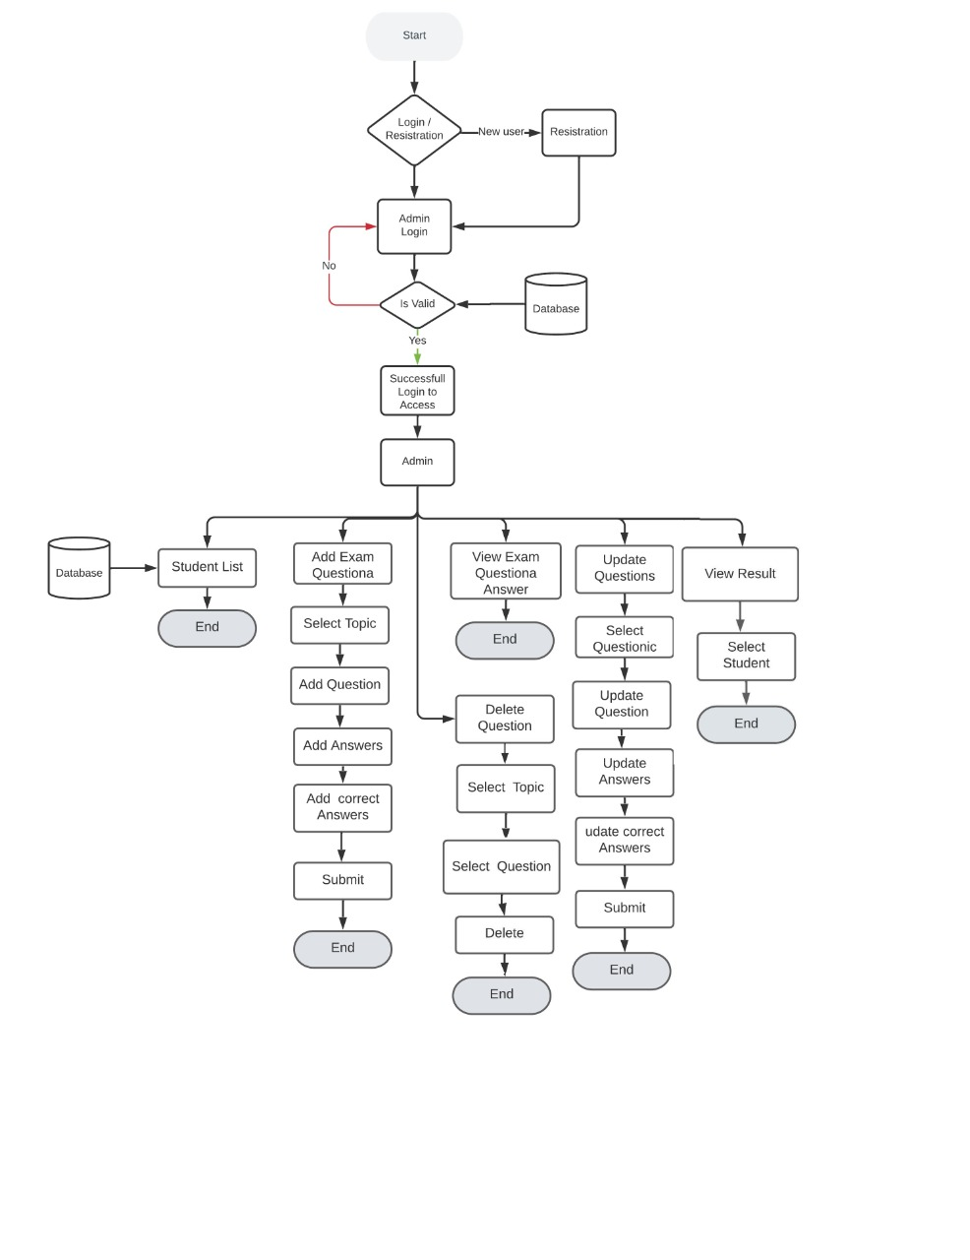

**STUDENT DATA FLOW DIAGRAM:**

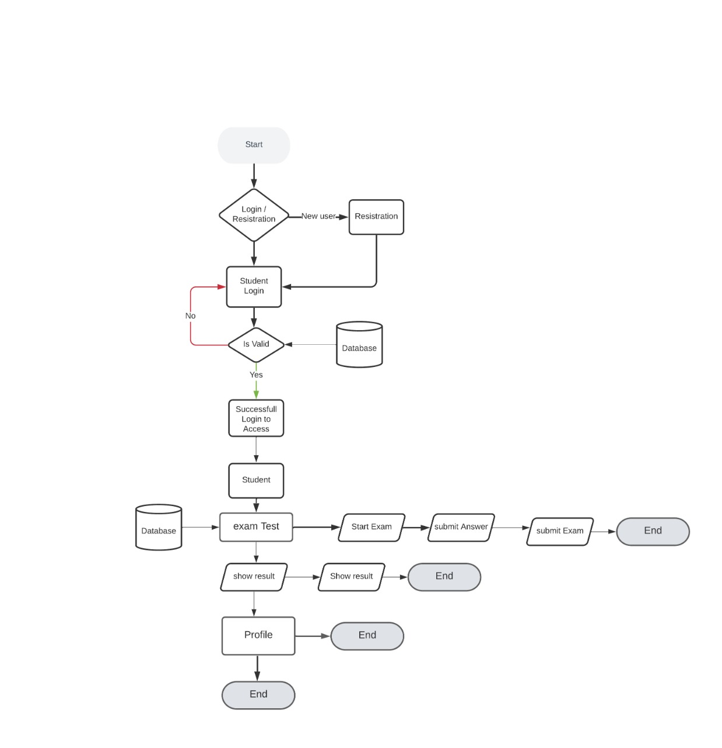

**ADMIN ACTIVITY DIAGRAM:**

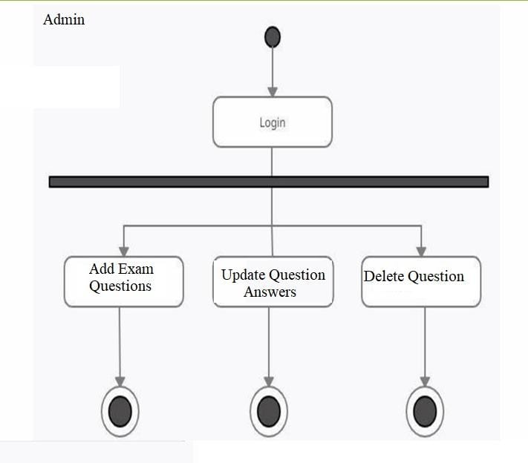

**STUDENT ACTIVITY DIAGRAM:**

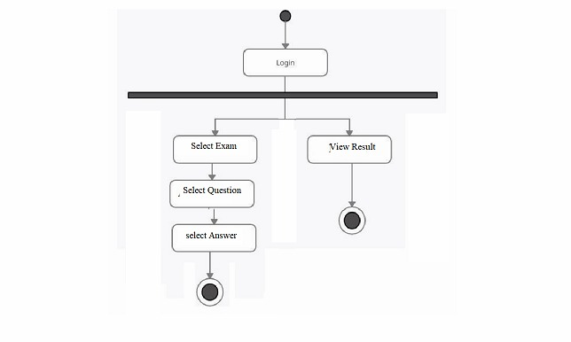

**ER DIAGRAM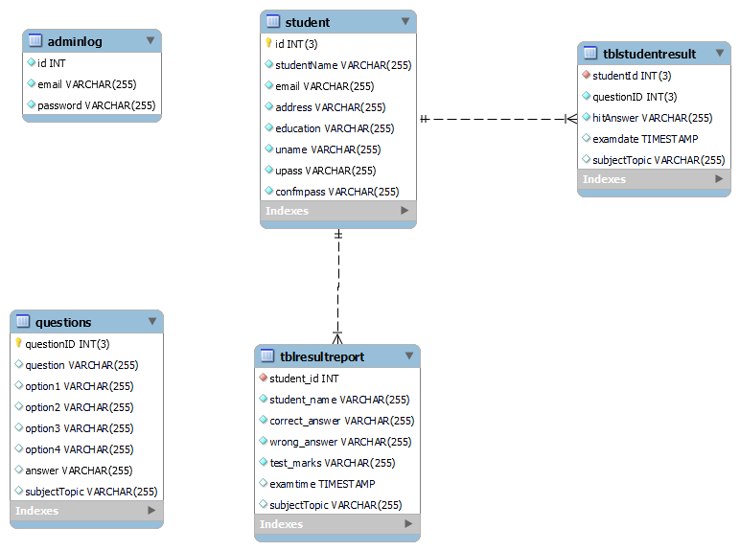:**

**Appendix**

**Glossary**:

|  |  |  |
| --- | --- | --- |
| **Sr.No. Abbrevations Full Forms** | | |
| 1. | SRS | Software Requirements and Specifications |
| 2. | ANSI | American National Standards Institute |
| 3. | IEEE | Institute of Electrical and Electronics Engineers |
| 4. | HTML | HyperText Markup Language |
| 5. | CSS | Cascading Style Sheets |
| 6. | JS | Java Script |
| 7. | HTTP/HTTPS | Hypertext Transfer Protocol/Hypertext Transfer Protocol  Secure |
| 8. | SQL | Structured Query Language |
| 9. | JSP | Java Server Pages |

**Thank You…!**